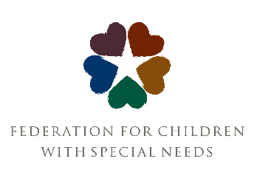

Strategic Planning Process: Phase 1 Timeline

Process Step | Participants | Dates/Deadlines
Survey of all Stakeholders: Staff, Board, Volunteers, Families, Partners | 79 Individuals | DONE (Spring-  Summer 2023)
FCSN Staff invited to recommend stakeholders for consultant interviews | Staff | DONE (Summer 2023)
Interviews with external stakeholders | 24 Individuals | DONE (Fall 2023)
Report and Process Timeline from Consultant shared with Board via email. Request 2-3 board volunteers to participate in Core Values working group. | Board | December 6, 2023
Report and Process Timeline shared with Staff | Staff | December 6, 2023
Presentation and discussion of Report and Timeline. | Staff | December 12 All Staff Meeting
Presentation and discussion with FCSN Board of Directors. | Board | January 8
Recruit members of Core Values Working Group and hold mini-retreat to create a first draft of Core Values | 8-10 Staff  2-3 Board | January 18, 2024  11am – 1pm
Draft Core Values discussed in a series of small group meetings including 8 for staff and 1 for the full Board. | All Staff  Full Board | Completed by February 8
Administrative Leadership Team, Executive Director, Board representatives, and consultant finalize core values to send to the board. | Designated Leaders | February 29-10:30am
Board Meeting to discuss and vote on core values. | Board | March 18
In Person Mission Statement generation meeting with Federation Staff and Board. Vision Statement will also be discussed and potentially revised. | All Staff  Full Board | March 21 (tentative date of March all staff)
Subcommittee is appointed by the Executive Director to wordsmith final draft of changes agreed upon in the Mission Statement meeting. | Designated Staff | April 10
Final Mission Statement shared with staff and Board via survey to solicit final comments. | Board and Staff | Survey Open  April 12-26
New Mission Statement approved by Board | Board | May 20
A task force convened by the Executive Director proposes 3 – 5 options for a New Name for the Federation. | Staff and Board | Proposals due May 30
Staff surveyed on proposed options for a New Name. | Staff | June 4 - June 11
Board votes on a New Name for the Federation. | Board | June 17 (tentative)

