September All Staff Meeting:

Charts and Comments
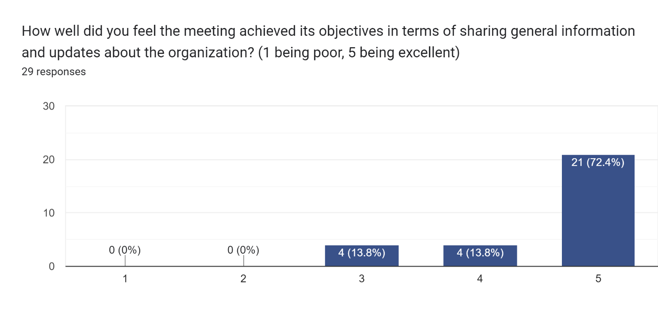

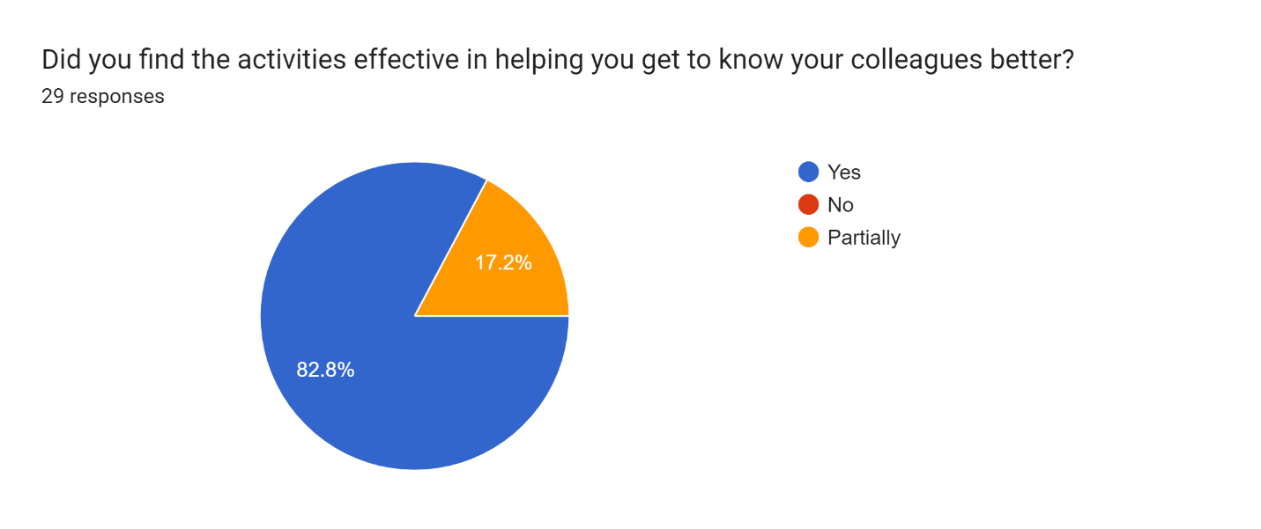
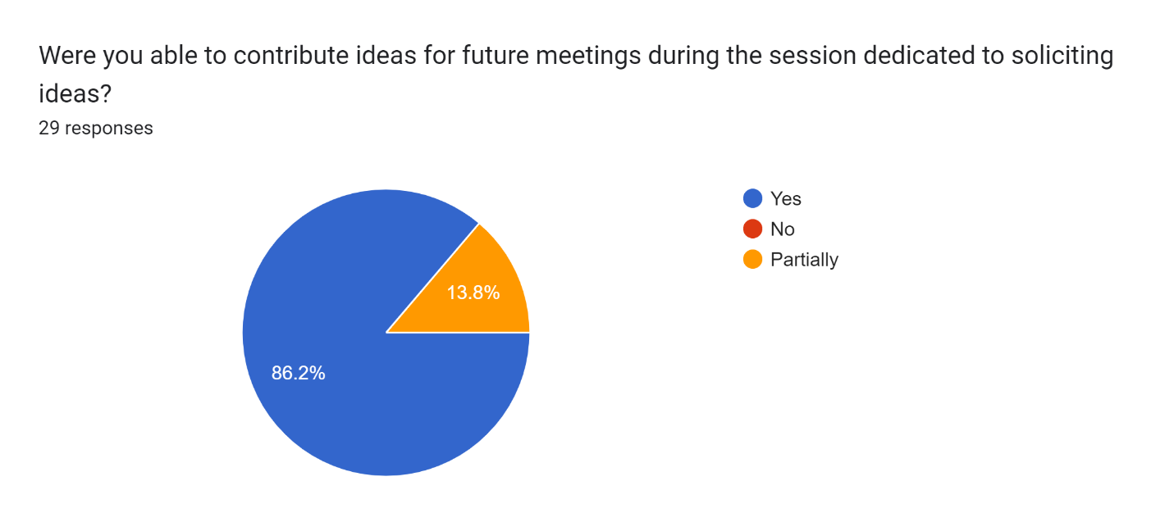
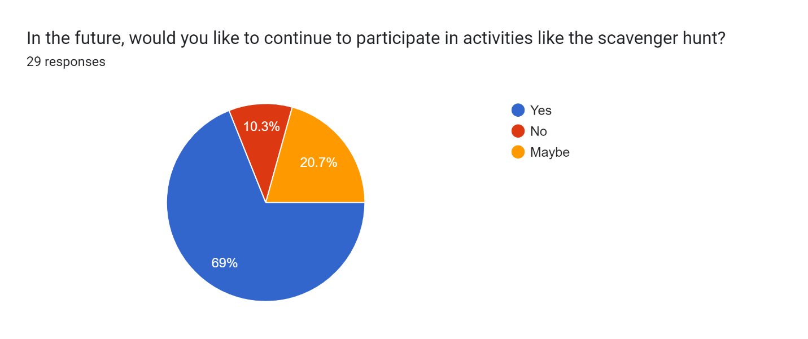
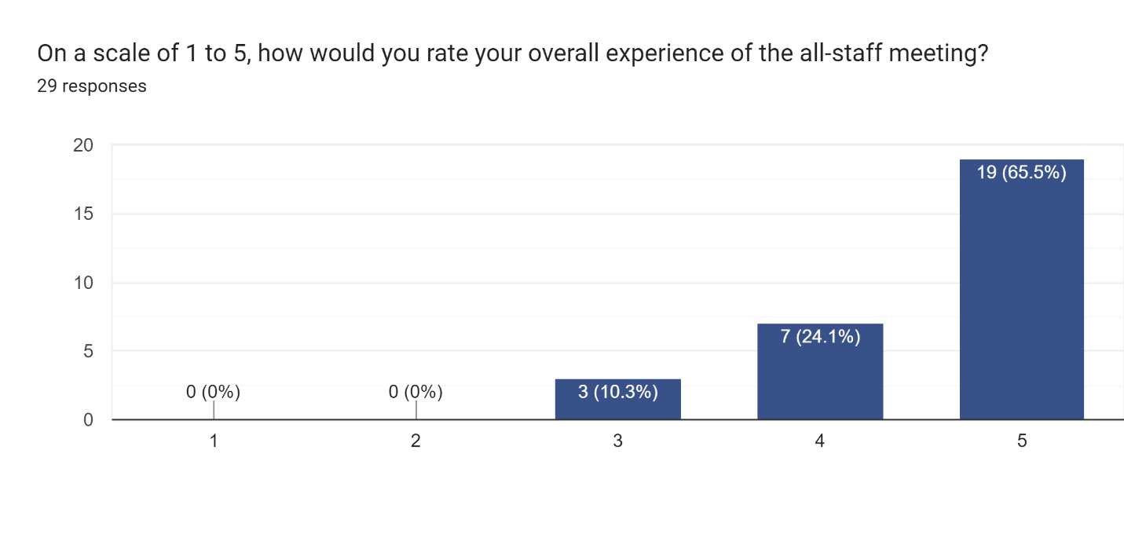

How can we make it easier for you to share your ideas for future meetings in the future?
- Have a suggestion email address so when the idea is fresh in my mind, I can submit and not have to wait for a specific date.
- Maybe a form in the portal?
- "Suggestion Box"?
- not sure
- Share questions and what you're looking for feedback about in advance to give time for processing/reflection
- I really liked the sticky wall and gratitude wall. I think emphasizing gratitude every time is a great way to set the tone.
- The sticky board works well for me
- Send out a survey before the meeting to find out what are things anyone would like to talk about after the announcements.
- google form
- I like to be able to give feedback anonymously
- Maybe include a step to review suggestions, and provide a way to +1/agree with other people's suggestions
- Is there a point person that does the agenda that we could reach out to? or maybe set it up as one of the options in the One Federation Service Request thing -
- No need to change.
- prior knowledge of what we will be asked to contribute to so I can think about it before hand
- What aspects of the meeting did you find most valuable or enjoyable?
group activities to get to know each other
- activities which helped us connect, especially with new staff
- Organizational updates, and small groups to get a chance to connect with staff I don't typically meet with.
- The activities, and FCSN updates
- the fcsn history video and activities
- Lunch, Video,
- Vision exercise everything really. best meeting in a long time!
- I had the opportunity of meet a lot of coworkers in persone for the fist time or that I haven’t seen in a while
- I enjoyed and appreciated that the activities focused on getting to know one another specifically as it relates to our work here
- Getting to talk to staff I don't get to work with on a regular basis / Seeing that marvelous video
- It was nice to say hello in person to people I've met on-line. However, because of the distance involved, an annual meet and greet would be sufficient for that. Alternatively, we could have staff go to different geographic locations, ie a Boston group, a Southeast MA group, a West of Worcester group and Zoom into the All Staff from there.
- I like meeting people from other programs and finding out about what brings them to the Federation
- The activities that had us all interacting
- The videos about the organization and interaction with others.
- The whole thing! Truely! I was recently hired, and I feel so lucky and blessed to be a part of the Federation. I even had some tearful moments during the All Staff meeting in learning more about FCSN and its wonderful staff!
- Getting the chance to collaborate in-person
- The casual conversations and time to just chat.
- small group discussions
- Networking and getting to know the people we work with.
- stand up sit down activity -
- To meet all staffs
- It was nice to meet people in person.

Do you have any additional comments or feedback about the meeting that you'd like to share?
- I wonder if we can start at 11:00 to allow people more time to drive in.
- bring back the potluck portion of sharing breakfast or dessert
- Thank you!
- Not at this time.
- I love visuals and to follow a powerpoint that shows visual accomplishments and future goals of each "division" would be awesome
- I think it's Fantastic that Renee and Cambria are splitting duties to support/supervise the PDs. Adding this level of operational leadership will definitely take the Federation to the next Level! Exciting times ahead!
- Would love to receive an agenda in advance, even if it's pretty general, so I can come to the meeting prepared to participate as fully and effectively as possible
- Take a picture of the group on the steps of the Schrafft Center
- As a newbie to FCSN and because so many FCSN roles often change, getting updates about funding/grants and an org chart would be really helpful. This could be sent out ahead of time so people could ask questions.
- It would also be helpful for each program to introduce the different Teams and their members and a brief synopsis of what each group does. I would also like to connect more with staff in specific geographical areas. For ex, as Info Ctr in Western MA, I would like to chat with Family Ties in Western MA. This would lead to better collaboration.
- There was lots of clapping, so I think that is a good sign!
- Thanks for everything! Look forward to the next gathering!
- I appreciated the many efforts to include/educate new staff and create/re-establish FCSN culture post Covid.
- I think doing this virtually to be inclusive and make better use of our time could be done too. Zoom break out rooms for more of the team building activities/games could be done. I think the goal of building connection and knowing more about our coworkers, who they are and what they do is so important and enjoyable. However I do not believe we have to be in person to achieve this.
- I am appreciative of the time and efforts put into making this event enjoyable.
- It was fun.
- I am grateful to be a part of such an amazing organization.
- I understand the desire to get the staff together and to learn more about the organization, however, I would not work for a company that was in Boston for the reason, I hate getting to Boston. Perhaps, since this is a statewide agency, some of the staff meetings could be more centrally located.

